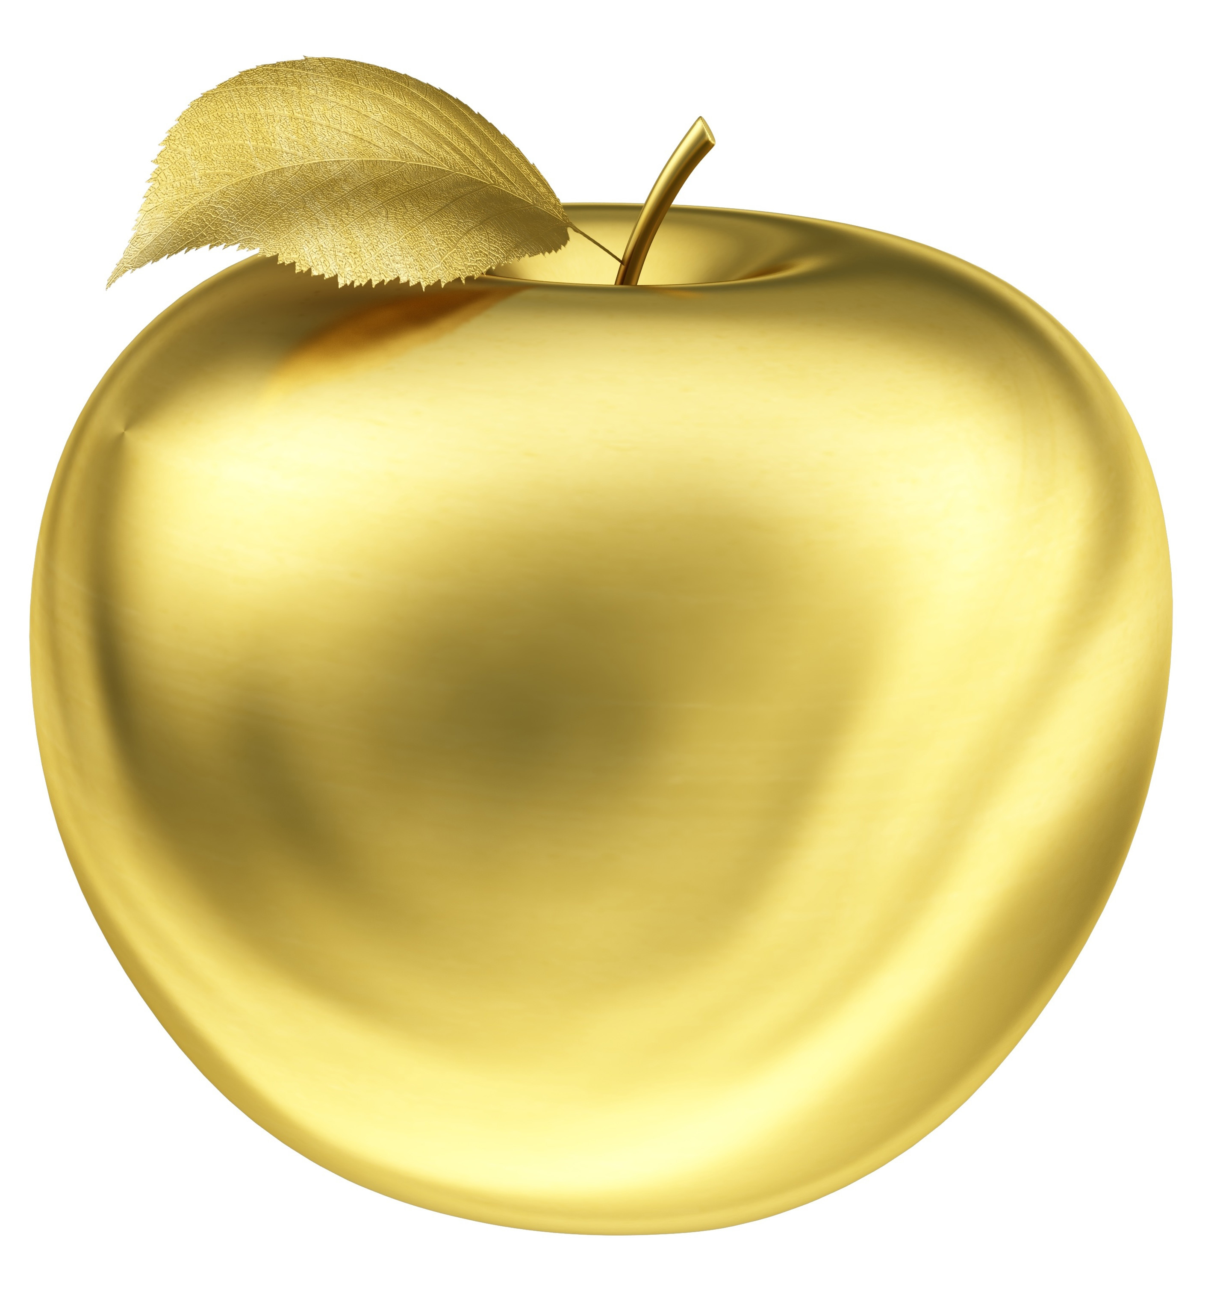

ELDORADO HIGH SCHOOL
GOLDEN APPLE AWARD

_______________________________________

Congratulations! We would like to award you with the EHS Educators Rising Golden Apple. Thank you for inspiring, encouraging, and empowering your students in every way. Thank you for being our teacher.

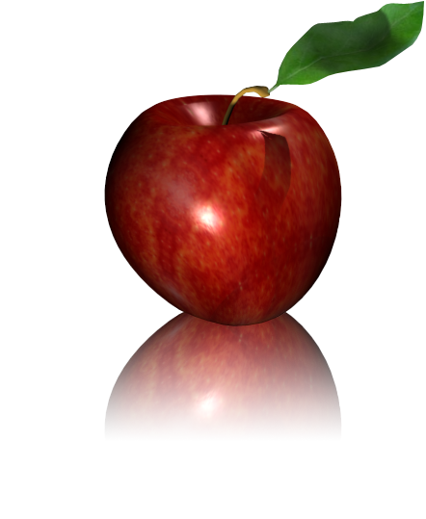
Eldorado High School
Educators Rising
Feature Teacher!

Dear Teachers,
The FEA Chapter would like to feature a teacher each week on the announcements. Names of teachers returning forms will be drawn randomly from a box. During the week you are featured, you will receive a small treat/gift. Please return forms as soon as possible so you can be included.

Name:__________________________________________________________________
Room:_________________________________________ Extension:________________
Subject(s) taught:_________________________________________________________
Educational Background:___________________________________________________
________________________________________________________________________
Year(s) taught & where:____________________________________________________
Comments about teaching:__________________________________________________
________________________________________________________________________
_______________________________________________________________________
Spouse/children:__________________________________________________________
Hobbies:________________________________________________________________
Favorite book:____________________________________________________________
Favorite music / singer:_____________________________________________________
Favorite anything else!:_____________________________________________________
Please share any of your interests that may not be listed above:_____________________
________________________________________________________________________
________________________________________________________________________
________________________________________________________________________

Thank You!
Educators Rising give thanks to one and all,
teaching & mentoring EHS students this fall.
You want us to listen, learn and think,
you say to our future lives it will link.
For your love & care we give this favor,
to us, you are a life saver!

Thank You!
Educators Rising give thanks to one and all,
teaching & mentoring EHS students this fall.
You want us to listen, learn and think,
you say to our future lives it will link.
For your love & care we give this favor,
to us, you are a life saver!

Thank You!
Educators Rising give thanks to one and all,
teaching & mentoring EHS students this fall.
You want us to listen, learn and think,
you say to our future lives it will link.
For your love & care we give this favor,
to us, you are a life saver!

Thanks for the
ROLL you play
each day!

Thanks for the
ROLL you play
each day!

Thanks for the
ROLL you play
each day!

