[](http://www.deviantart.com/download/23557934/Cat_in_the_Hat_by_draygyn.jpg)

What is Educators Rising?



**Educators Rising** is an extra-curricular club offered to all students at Eldorado. ED Rising offers opportunities for students to interact with educators and other students at local schools & gain an understanding of he education profession.

What we do.. do...

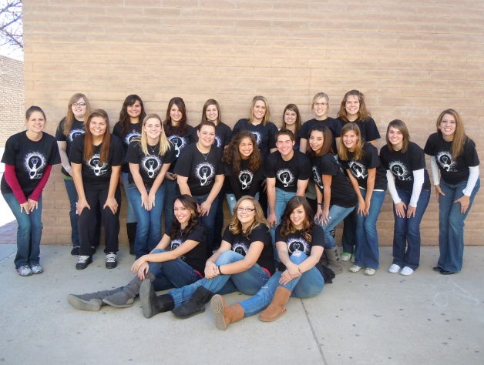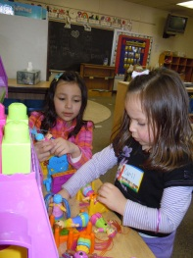[](http://www.deviantart.com/download/23557934/Cat_in_the_Hat_by_draygyn.jpg)[](http://www.graduationsource.com/media/catalog/product/cache/1/image/5d38899a914f89c9806d86fe01f5f229/p/u/purple_single_cord-base.jpg)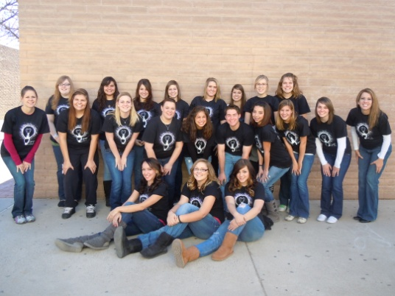

* In the past, ER granted $2,000 in scholarships to seniors from our annual 5K “CHALK WALK”!
* Members have the opportunity to earn a letter and bar!
* ER is an Honor Society, providing the chance for students to receive an honor cord!
* Firsthand experience with students and educators!

What’s in it for me? me?you?

Here are just a few of the events and activities that our ER members provide:

* **Participate** in state and national conferences!
* **Parents Day Out:** Parents take the day off and our ER members plan and lead a whole day of activities!
* **Teacher Challenge:** Students challenge teachers to perform crazy dares at an assembly!
* **Kids in the Kitchen:** cooking activities for elementary aged children!
* **Dr. Seuss Day:** ER members visit classrooms and read Dr. Seuss stories and lead activities!
* **Tutoring:** Members tutor elementary students at local schools.

Wanna Join?

**Email us!** Our Educators Rising Advisors are Mrs. Blatner (blatner@aps.edu) and

Mrs. Escobedo (Escobedo_j@aps.edu)

**Call us:** 505-296-4871 x 1410

**“LIKE” us on Facebook**—search “Keep Calm & Just Teach”!

**Visit us:** Mrs. Blatner’s room in

v-11 or Mrs. Escobedo’s room in z-1

MCj04104810000[1]**Educators Rising Member & Potential Member!**

**Your name is on our Ed Rising member roster. We are currently compiling a list of students who are interested in participating in Ed Rising NEXT year, we would like to know if you are interested in participating again next year or whether to take your name off of our Remind 101 list!!**

**Please return THIS completed form to Mrs. Blatner in V-11, the preschool portable or her mailbox ASAP so that we may add you to the list and let you know about our Back to School events at local elementary schools via REMIND 101!**

**Sincerely,**

**The Ed Rising Leadership Team**

YES! Please add me to the 2016-2017 Member Roster!

Name:________________________________________________

Year in school during 2016-2017:___________________________

Cell Number :__________________________________________

Email :_________________________________________________





