NEW EDUCATORS RISING MEMBER TO DO LIST:

- Register online (IMPORTANT!): https://www.educatorsrising.org/virtualcampus/registration and create a NEW account. Use the school zip code & look for our chapter of Educators Rising.
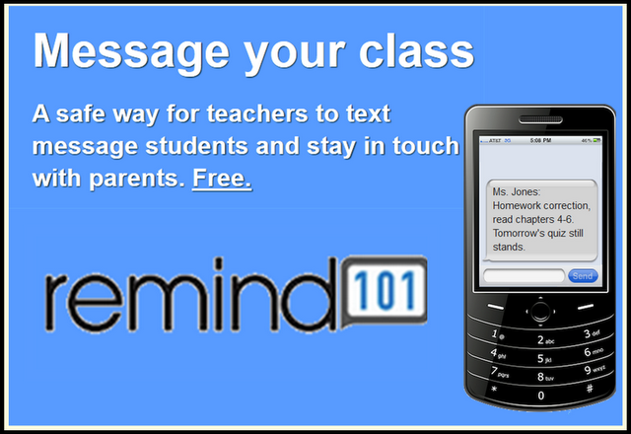
- Register for our Educators Rising Remind 101 group:
  - Using your phone, send a text to: 81010
  - Text the message: @edrisin

- Join/follow/”like” our social media sites:
  - National Ed Rising Twitter page: @EducatorsRising
  - Take pictures & tag them when you are participating in EdRising events!

- Attend Meetings held every other Friday (unless we have special events we are preparing for!) – come to V-11

- Check the EdRising bulletin board in V-11, sign up to participate – track your hours & get participation signatures if you plan to Letter or Bar in EdRising.

- Visit www.aps.edu/volunteer-with-aps and start the process of getting a background check to allow you to volunteer in a local elementary school! See Mrs. Blatner for specific directions.

- Pick up a volunteer log in V-11 to track your hours! If you volunteer a minimum of 25 hours you can qualify to earn an EdRising letter, bar or even an honor cord to wear at graduation!

- See Mrs. Blatner or Mrs. Escobedo for more information or how to get involved!

